**Installing the SpotBugs Plug-in:**

1. Open the Eclipse Marketplace dialog by selecting *Help -> Eclipse Marketplace...* from the main menu.

In the Eclipse Marketplace dialog:

1. Search for "SpotBugs." You should see SpotBugs at the top of the list:

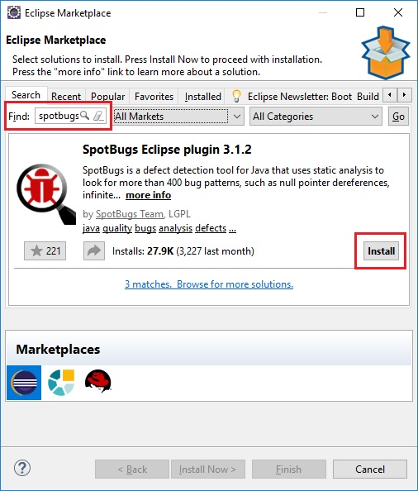

Click the *Install* button.

1. On the next screen, accept the terms of the license agreement and click the *Finish* button to install the plug-in.
2. You might get a dialog warning you that you are about to install unsigned content. click *Install anyway*.

After you restart Eclipse, you'll be the proud owner of some free software!

## Running SpotBugs on a Project :

To apply SpotBugs to a project:

1. Right-click the project in the Package Explorer, Then, select *SpotBugs -> Find Bugs* from the context menu.

After the analysis has concluded, the results will be presented in the Bug Explorer view.

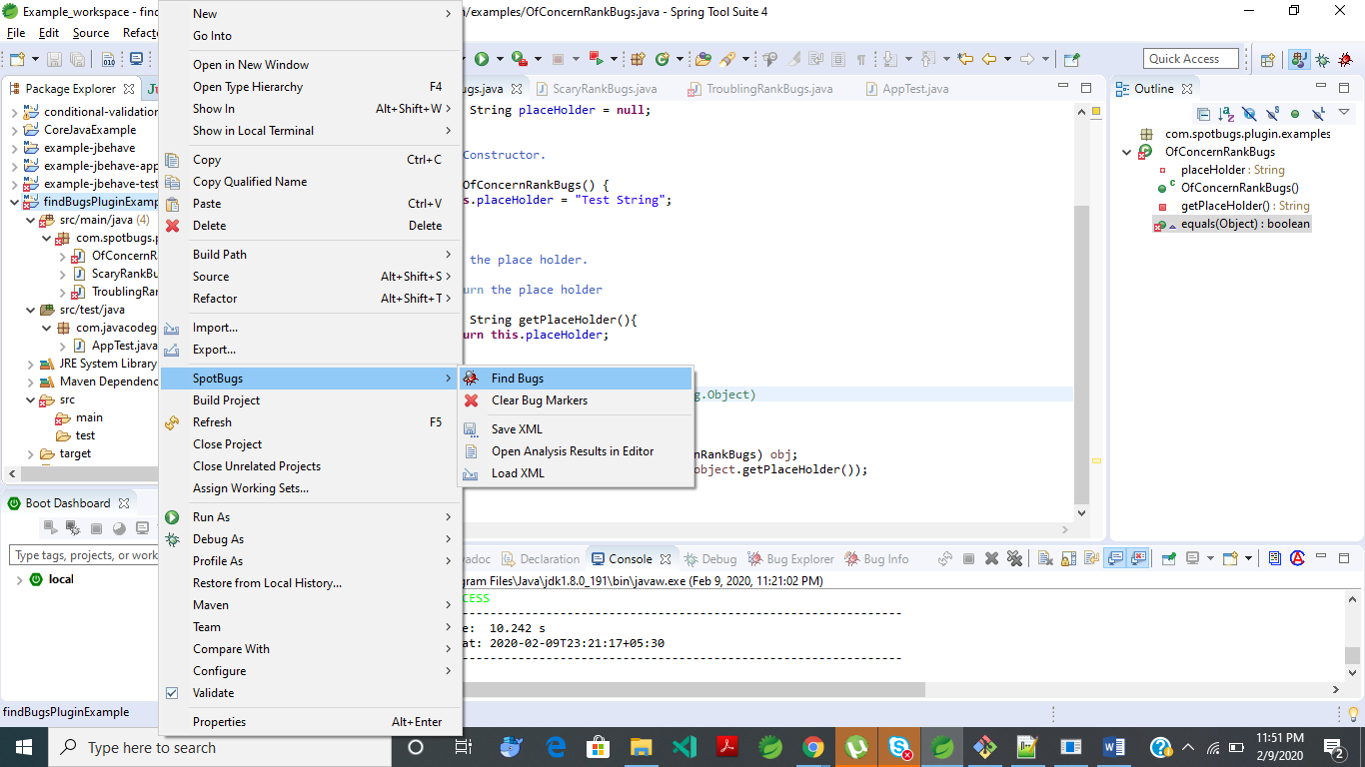

### Obtaining More Information on a Bug

Until you've been working with SpotBugs for some time, a bug like "ABadClass defines equals and uses Object.hashCode()" may not mean much to you. That's why SpotBugs includes a lot more information on each problem. To see it, right-click the bug and select Show Bug Info from the popup menu. That will bring up an info page in the Bug Info view

## 

## Bug Explorer:

## 

## Bug Information :

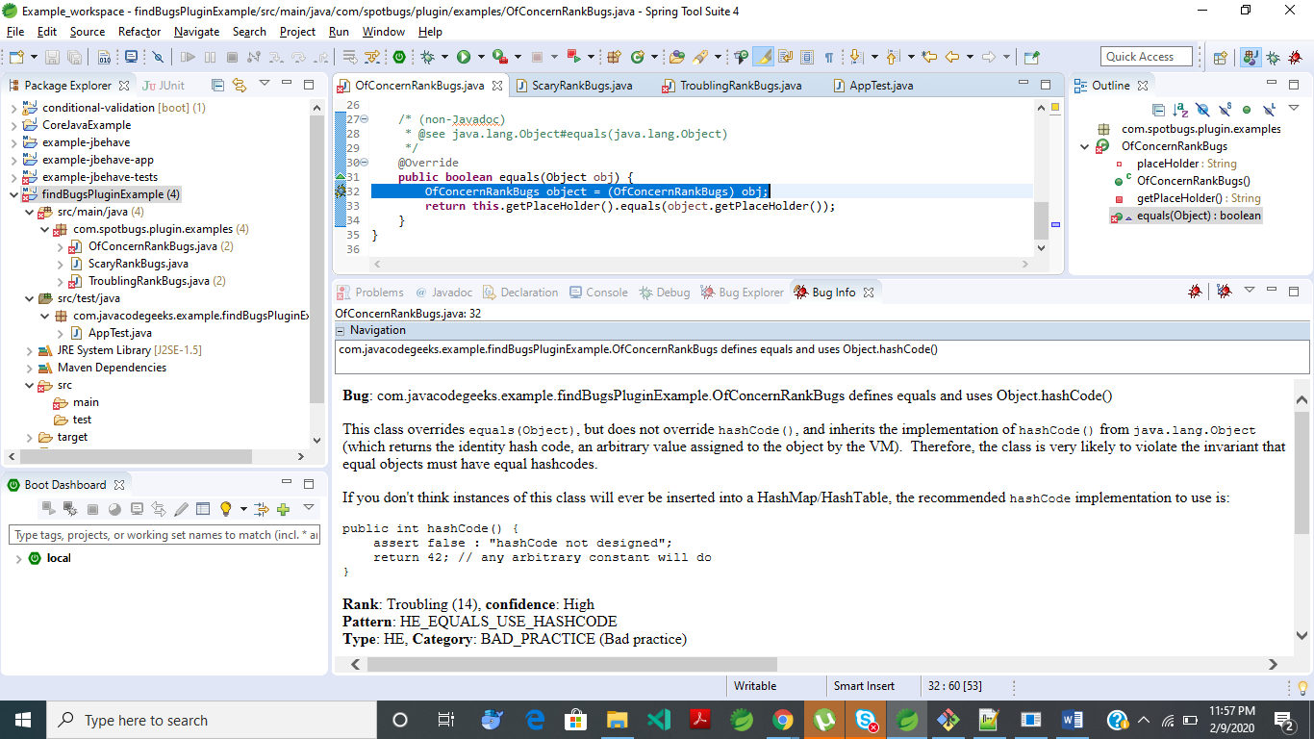

## Configuring SpotBugs Settings:

The FindBugs plug-in makes it easy to customize the bugs analysis strategy, by offering various ways to filter warning and limit the strictness of the results. You can check the configuration interface by going to Window -> Preferences -> SpotBugs:

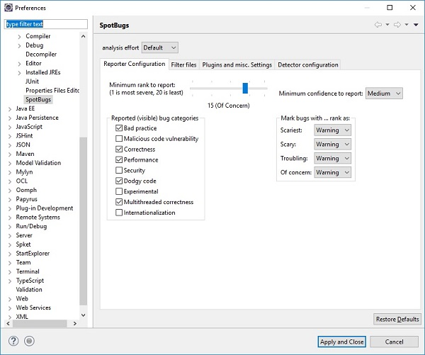

The easiest way to alter the number of bugs reported is to use the Minimum rank to report slider. The further right it's set, the more bugs will be reported. Conversely, the further left it's set, the fewer bugs you'll see. That's because the minimum rank threshold rises as the slider moves to the left. You'll see the minimum change as you go, from "Of concern," to "Troubling," to "Scary," and finally, to "Scariest." Each category is divided into five levels of rank.